NATIONAL UNIVERSITY OF MODERN LANGUAGE ISLAMABAD
Assignment : 01


Submitted to:
Ms Sana Gul
Submitted by:
Zulqarnain Hassan
Roll No: …………………… SP21379
Subject: …………………… Visual Programing
Department: ……………… BSSE-5-Afternoon
Date: ……………………… 12-5-2025

Q1: Write code for to establish database connection in asp.net application
namespace my_app
{
public partial class Form1: Form
{
public Form1()
{
InitializeComponent();
}

private void add_Click(object sender, EventArgs e)
{
String address = "Data Source=(LocalDB)\\MSSQLLocalDB;Initial Catalog=STUDENT;Integrated Security=True";

SqlConnection con = new SqlConnection(address);

con.Open();
SqlCommand cmd = new SqlCommand("INSERT INTO std_record (ID, FIRST_NAME, LAST_NAME) VALUES ('"+id.Text+"','"+fname.Text+"','"+lname.Text+"') ", con);

cmd.ExecuteNonQuery();
MessageBox.Show("Data Inserted Successfully");
con.Close();

}

private void view_Click(object sender, EventArgs e)
{
String address = "Data Source=(LocalDB)\\MSSQLLocalDB;Initial Catalog=STUDENT;Integrated Security=True";

SqlConnection con = new SqlConnection(address);

con.Open();
SqlCommand cmd = new SqlCommand("select * from std_record ", con);
var data = cmd.ExecuteReader();
DataTable dt = new DataTable();
dt.Load(data);
gridview.DataSource = dt;

con.Close();
}

private void update_Click(object sender, EventArgs e)
{
String address = "Data Source=(LocalDB)\\MSSQLLocalDB;Initial Catalog=STUDENT;Integrated Security=True";

SqlConnection con = new SqlConnection(address);

con.Open();
SqlCommand cmd = new SqlCommand("UPDATE std_record SET FIRST_NAME='" + fname.Text + "', LAST_NAME='" + lname.Text + "' WHERE id = '" + id.Text + "' ", con);

cmd.ExecuteNonQuery();
MessageBox.Show("Data updated Successfully");
con.Close();
}
}
}

Output screenshots
form
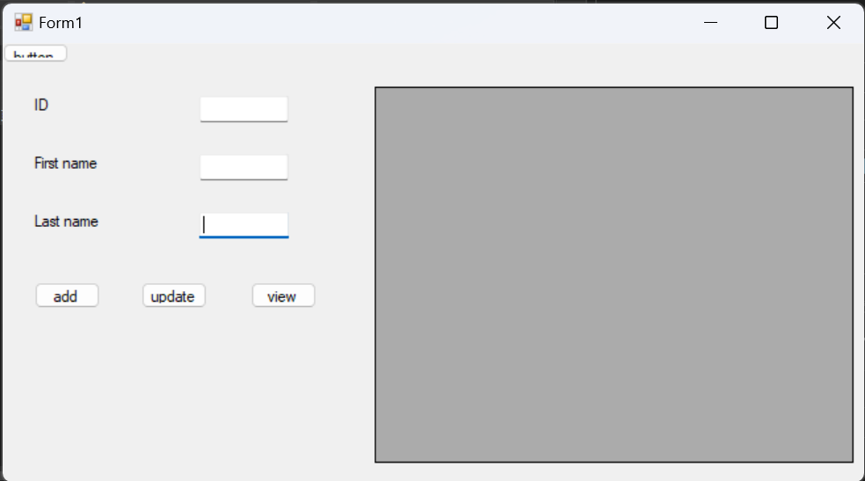

View
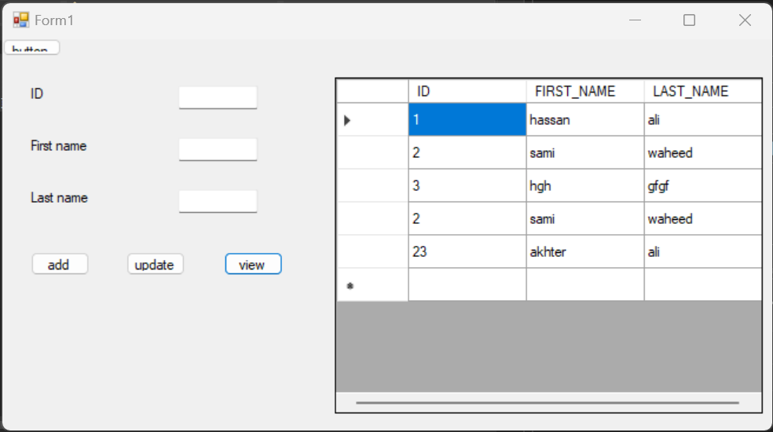

For insertion
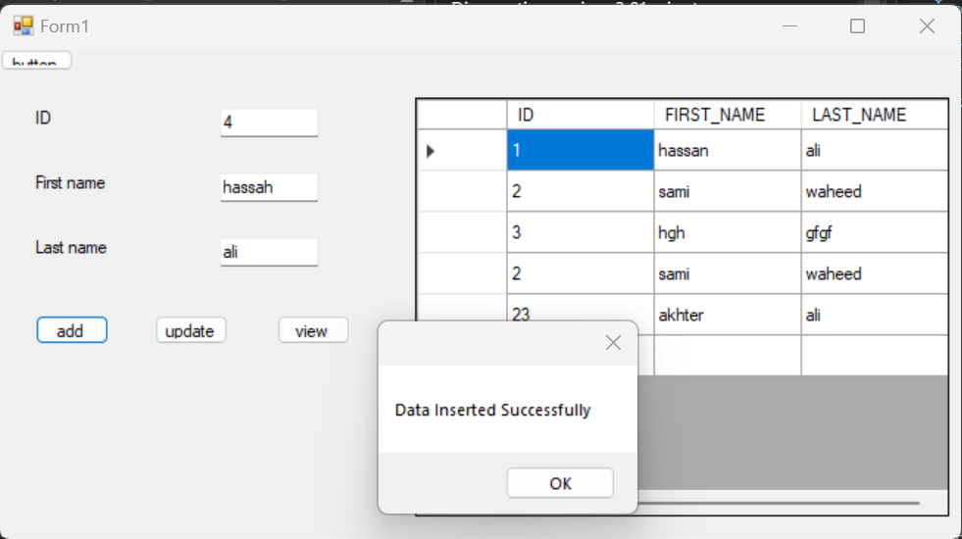

For update
